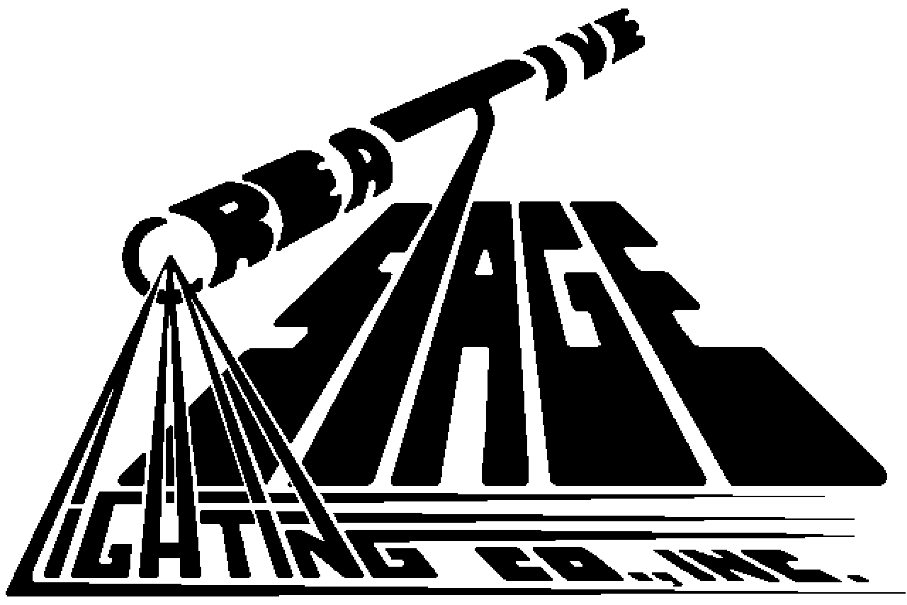
Creative Stage Lighting Co., Inc.
P.O. Box 567
Route 28N
North Creek, NY USA 12853
Tel: 518.251.3302
Fax:518.251.2908 24 Hours
www.creativestagelighting.com

PRODUCT SPECIFICATION

DURA-FLEX Part Number: 12/142586

Product Description : A Twelve (12) Gauge -- Fourteen (14) Conductor -- Bare Copper With PVC Insulation, Reverse Planetary Laid, Rugged, Oil Resistant, PVC Jacketed, Yet Highly Flexible Instrumentation Cable.

Conductor Data:
Material Bare Copper
Gauge 12 AWG
Stranding 65 x 30

Insulation Data:
Material Polyvinylchloride
Nominal Wall Thickness .022”
Diameter (primary) .140”

Cabling Data:
Number Of Conductors 14
Conductor Identification Cond. 1 Red, No Number
Cond. 2 - 12 White, Black Number
Cond. 13 Green
Cond. 14 Green With Yellow Stripe
Center Filler Polyvinylchloride / Black
O/A Tissue Tape

Jacket Data:
Material Polyvinylchloride (Oil Resistant)
Color Black
Markings White Lettering, Also Indented
Nominal Wall Thickness .080”
Diameter (O.D.) .785”
Legend DURA-FLEX 12AWG 14/C RU AWM STYLE 2586 600V 105C VW-1 E167231-A
---- CSA AWM I A/B II A/B 105C 600V FT1 LL71737

Product Ratings:
Weight .535 lbs./ft.
Temperature Range -20°C to 105°C
Voltage 600 Volts
UL Approval RU AWM STYLE 2586 600V 105C
CSA Approval CSA AWM IA/B IIA/B 105C 600V FTI

